Question 1)

a)

public class Example {

public static void main(String[] args) {

double value_1 = 300.0;

byte value_2 = (byte) value_1;

System.out.println("value_2 = " + value_2);

}

}

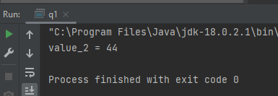

Because value_1 is a double type variable and value_2 is a byte type variable so when it converting double into byte its will be change the actual value . because byte can only hold -128 to 127 .so it can’t convert 300.0

b)

public class Example {

public static void main(String[] args) {

long value_1 = 2147483648L;

int value_2 = (int) value_1;

System.out.println("value_2 = " + value_2);

}

}

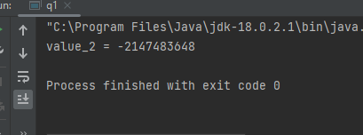

Because long data type in java is a 64bit signed integer ,while an int type is 32 bit signed integer .that’s why its generate negative value when its convert.

c)

public class Example {

public static void main(String[] args) {

short value_1 = -150;

byte value_2 = (byte) value_1;

System.out.println("value_2 = " + value_2);

}

}

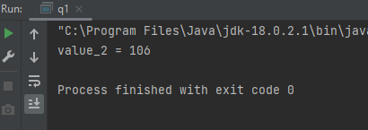

Because value_1 is a short type variable and value_2 is a byte type variable so when it converting short into byte its will be change the actual value . because byte can only hold -128 to 127 .so it can’t convert -150

d)

public class Example {

public static void main(String[] args) {

char value_1 = 169;

byte value_2 = (byte) value_1;

System.out.println("value_2 = " + value_2);

}

}

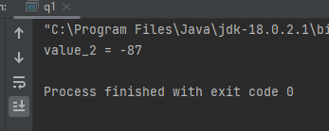

Because value_1 is a char type variable and value_2 is a byte type variable so when it converting char into byte its will be change the actual value . because byte can only hold -128 to 127 .so it can’t convert 169

Question 2)

public class q2 {  
 public static void main(String[] args) {  
/*  
 System.out.println("employeeName = " + args[0]);  
 System.out.println("employeeId, hoursWorked = " + args[1]+" "+ args[2]);  
 System.out.println("hourlyRate = " + args[3]);  
*/  
 String employeeName = args[0];  
 int employeeId = Integer.*parseInt*(args[1]);  
 int hoursWorked = Integer.*parseInt*(args[2]);  
 double hourlyRate = Double.*parseDouble*(args[3]);  
  
 double grossSalary = hourlyRate * hoursWorked;  
 final double TAX_RATE = 0.1;  
 double taxDeduction = grossSalary * TAX_RATE;  
 double netSalary = grossSalary - taxDeduction;  
  
 System.*out*.println("-----------------------------------");  
 System.*out*.println(" Employee Pay Sheet ");  
 System.*out*.println("-----------------------------------");  
  
  
 System.*out*.println(" Employee Name: "+employeeName);  
 System.*out*.println(" Employee ID: "+employeeId);  
 System.*out*.printf(" Hourly Rate: %.2f\n",hourlyRate);  
 System.*out*.println(" Hours Worked: "+hoursWorked);  
 System.*out*.printf(" Gross Salary: %.2f\n",grossSalary);  
 System.*out*.printf(" Tax Deduction: %.2f\n",taxDeduction);  
 System.*out*.println("-----------------------------------");  
 System.*out*.printf(" Net Salary: %.2f\n",netSalary);  
 System.*out*.println("-----------------------------------");  
   
 }  
}

Output

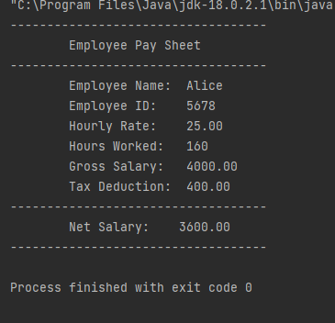

Question 3)

public class q3 {  
 public static void main(String[] args) {  
  
 double item1Price = Double.*parseDouble*(args[0]);  
 double item2Price = Double.*parseDouble*(args[1]);  
 double item3Price = Double.*parseDouble*(args[2]);  
  
 double TotalCost = item1Price+ item2Price +item3Price;  
 double DISCOUNT_RATE = 0.15;  
 double discountAmount = TotalCost * DISCOUNT_RATE;  
 double finalAmount = TotalCost - discountAmount;  
  
 System.*out*.println("-----------------------------------------------");  
 System.*out*.println(" Grocery Bill ");  
 System.*out*.println("-----------------------------------------------");  
  
 System.*out*.printf("Item 1 Price: %.2f\n", item1Price);  
 System.*out*.printf("Item 2 Price: %.2f\n", item2Price);  
 System.*out*.printf("Item 3 Price: %.2f\n", item3Price);  
  
 System.*out*.println("-----------------------------------------------");  
  
 System.*out*.printf("Total Cost: %.2f\n", TotalCost);  
 System.*out*.println("Discount (15%): -15.00" );  
  
 System.*out*.println("-----------------------------------------------");  
  
 System.*out*.printf("Final Amount: %.2f\n", finalAmount);  
  
 System.*out*.println("-----------------------------------------------");  
  
 }  
}

output

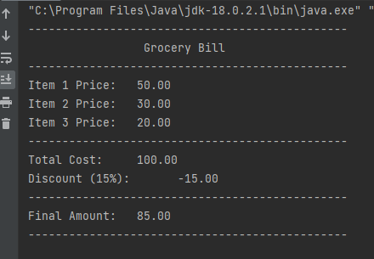

Question 4)

public class q4 {  
 public static void main(String[] args) {  
  
 double Celsius = Double.*parseDouble*(args[0]);  
 double Fahrenheit = (Celsius*(9/5.0))+32;  
  
 System.*out*.printf("Temperature in Celsius: %.2f°C\n",Celsius);  
 System.*out*.printf("Converted Temperature in Fahrenheit: %.2f°F\n",Fahrenheit);  
  
  
  
 }  
}

output

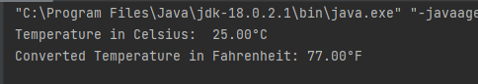

Question 5)

public class q5 {  
 public static void main(String[] args) {  
  
 double initialBalance = Double.*parseDouble*(args[0]);  
 double depositAmount = Double.*parseDouble*(args[1]);  
 double withdrawalAmount = Double.*parseDouble*(args[2]);  
  
 double finalBalance = initialBalance + depositAmount - withdrawalAmount;  
  
 System.*out*.println("-----------------------------------------------");  
 System.*out*.println(" Bank Account Summary ");  
 System.*out*.println("-----------------------------------------------");  
  
 System.*out*.printf("Initial Balance: %.2f\n",initialBalance);  
 System.*out*.printf("Deposit Amount: %.2f\n",depositAmount);  
 System.*out*.printf("Withdrawal Amount: %.2f\n",withdrawalAmount);  
  
 System.*out*.println("-----------------------------------------------");  
 System.*out*.printf("Final Balance: %.2f\n",finalBalance);  
 System.*out*.println("-----------------------------------------------");  
  
 }  
}

Output

